ATTIVITA’ INGLESE 3^A-B (Prof. Balzano) N°4
CORREZIONE COMPITI ATTIVITA’ 2/3
2
LEGGI LA CORREZIONE E CONFRONTA CON QUELLO CHE HAI FATTO TU
Pag. 62 n°1
1-email; 2-Internet; 3-WIFI; 4-print; 5-computer; 6-address; 7-dot;
8-website

Pag. 63 n°1
1. hot air ballooning; paragliding; hang-gliding
2.surfing; snorkeling
3. skiing; rock climbing
4.tap on; swipe; drag and drop
5. print
6. post

Pag. 63 n°2
1. It’s just started to snow.
2. Jack’s nevereaten Japanese food.
3. Have you ever seen a llama?
4. Oh dear! I haven’t passed my exam.
5. Have they ever been abroad?

Pag. 63 n°3
1. Last Saturday I got up at 11.00.
2. Oh, you are back! Where have you been?
3. Come on! Mum has laid the table for dinner.
4. Hooray! Our team has won the tournament.
5. They visited Dublin a month ago.
6. My parents aren’t at home. The’ve gone shopping.

Pag 63 n°4
1. Have you been to the supermarke yet?
2.We’ve already seen tonight’s film on TV.
3. Luckily we’ve just made our beds.
4. Has Connor downloaded that app yet?
5. They haven’t finished their homework yet.
6. Anne’s already updated her profile.
Pag. 63 n°5
1. A. How long have we known Sophie?
B. We’ve known her since 2012.
2. A. How long has your father worked for a bank?
B. He’s worked for a bank for ten years.
3. A. How long have you been here?
B. I’ve been here for half an hour.
4. A. How long have you spoken German?
B. I’ve spoken German since I was 6.
5. A. How long have they been away?
B. They’ve been away since last June.
6. A. How long has Amelia had a dog?
B. She’s had a dog for two months.
Pag. 63 n°6
2-c; 3-e; 4-a; 5-f; 6-d
Pag.186 n° 1
1. go-karting; 2. snorkeling; 3. paragliding; 4. rafting; 5. parkour; 6. cheerleading
Pag 186 n° 2
1.made 2. gone 3. bought 4. seen 5. eaten 6. tried 7. taken 8. thought 9. spoken 10.worn
Pag.186 n° 3
1. have visited 2. haven’t bought 3. Has……studied, she hasn’t 4.have spoken 5. haven’t done 6. has left 7.Has…gone, he/she has
Pag 186 n°4
1.never 2. ever 3. been 4. gone 5. never 6. been
Pag 186 n°5
1. have washed 2. didn’t play 3. haven’t watched 4. didn’t go 5. Have you tried 6. Did you buy
Pag 186 n°6
1-c; 2-d; 3-a; 4-b

Su fotocopia
Writing for the exam
Es. n°4
a the date – 2
b the greeting – 3
c paragraphs about plans for Saturday – 5
d paragraph about plans for Sunday – 6
e closing greeting – 8
f introduction – 4
g invitation to write back – 7
h the signature – 9
i the sender’s address -1

Su fotocopia
Pag 8 n° 1 (risposta personale)
Pag. 8 n° 3
1. She wants to do French and German because she wants to study languages at university.
2. They are going to become tour guides.
3. He wants to become an apprentice in a garage and work on Formula One cars.
Pag. 9 n°1
1-b; 2-a; 3-d; 4-c
Pag. 9 n°2
2.accountant 3. hotel manager 4. electrician 5. secretary 6.waiter
7.vet (veterinary) 8. plumber 9. chef
3
Traduci le frasi, usando il Present Perfect
1. I have studied French.
2. We have been to the USA.
3. Jane has eaten Japanese food.
4. I have done paragliding.
5. The kids have tried surfing.
6. Have you ever worked in a supermarket?
7. Have you ever talked to the Italian teacher?
8. Have they ever watched sci-fi films?
9. Has Paul ever printed a document?
10. Have you deleted this file?

Inserisci FOR o SINCE
1. for 2.since 3.for 4.since 5.since 6. for

Pag 187 n°1
1. download 2. swipe 3. drag 4.turned
Pag 187 n°2
1. The bus has just left.
2. The students have just finished the exam.
3. I’ve just seen my friends.
4. You’ve just taken my phone.
5. The teacher has just told us our results.
6. We have just run a kilometre!

Pag. 187 n°3
1. I haven’t done my homework yet.
2. I’ve already phoned my mum.
3. We’ve already decided what to buy.
4. Have they sent you an email yet?
5. My friends haven’t arrived yet.
6. Have you uploaded your photos yet?

Pag 187 n°4
1. How long have you had your bike?
2. How long have you known your best friend?
3. How long has your dad had his car?
4. How long have your friends been members of the sports club?
Pag 187 n°5
1. for 2. for 3. since 4. since 5. since 6. for

Pag 187 n°6
a-4 b-5 c-1 d-2 e-3

ATTIVITA’ 4
Ricopia il testo dell’esercizio 1 sotto e svolgilo sul quaderno.
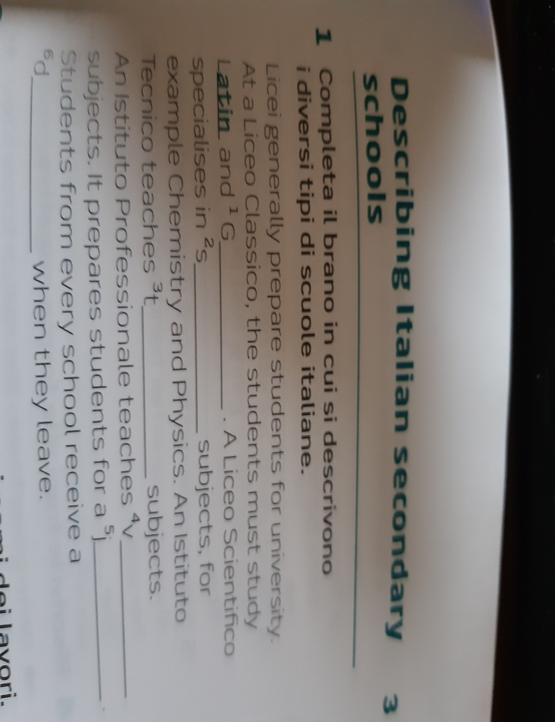

CIVILTA’ - GANDHI
Ascolta sul file audio la spiegazione in inglese su Gandhi, leggi il testo “Gandhi, a life for peace” delle due pagine di seguito, guarda “The march of salt” (la marcia del sale) su youtube al link https://youtu.be/G1_Dm1ZjRAM Mahatma Gandhi The Salt March [5’:01’’] poi rispondi alle domande e svolgi l’es. n°3 sul quaderno.
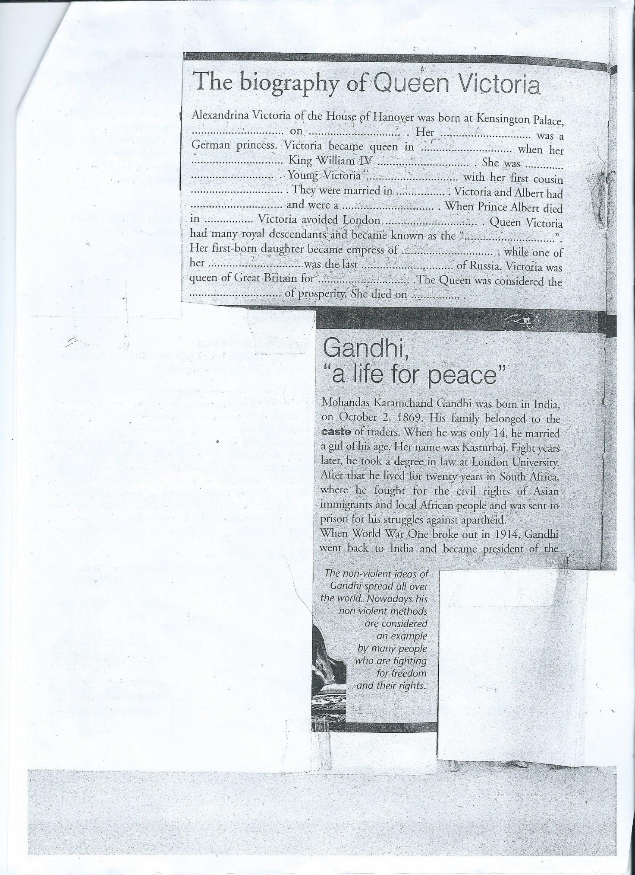

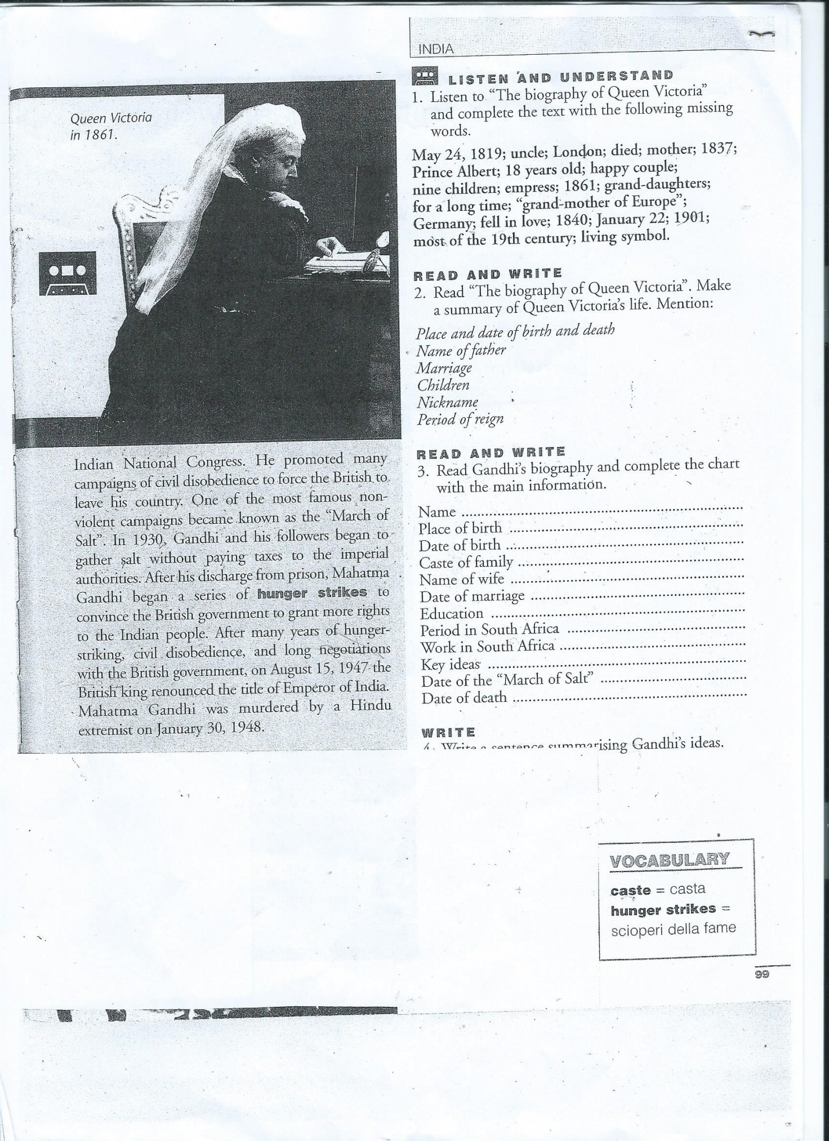

Questions
1. When did Queen Victoria rule Britain?
2. Where and when was Gandhi born?
3. Where did he study?
4. What did he take a degree in?
5. Why did he live in South Africa?
6. What happened in 1914?
7. What kind of campaigns did Gandhi organise?
8.What was one of Gandhi’s most famous campaign?
9. When was it? And what did Gandhi and his followers do?
10. What did Gandhi do to press the British government?
11.Who renounced the title of Emperor of India?
12. When did India become indipendent from the British?

