ATTIVITA’ INGLESE 3^A-B (Prof. Balzano) N°5

Correzione compito: domande su Gandhi
1. She ruled Britain from 1837 to 1901.
2. He was born in 1869 in India.
3. He studied at London University.
4. He took a degree in law.
5. He lived in South Africa because he wanted to fight for the civil right of the Asian immigrants.
6. In 1914 World War I broke out and Gandhi went back to India.
7. He organised non-violent campaigns of civil disobidience.
8. It was The Salt March.
9.It was in 1930. Gandhi and his followers gathered salt without paying taxes to the local authorities.
10. He organised hunger-strikes.
11. King George V.
12. It became indipendent in 1947.

LEZIONE N°5
This lesson is on Australia because it was a British colony and English is the national language.
Look at the map of Australia.
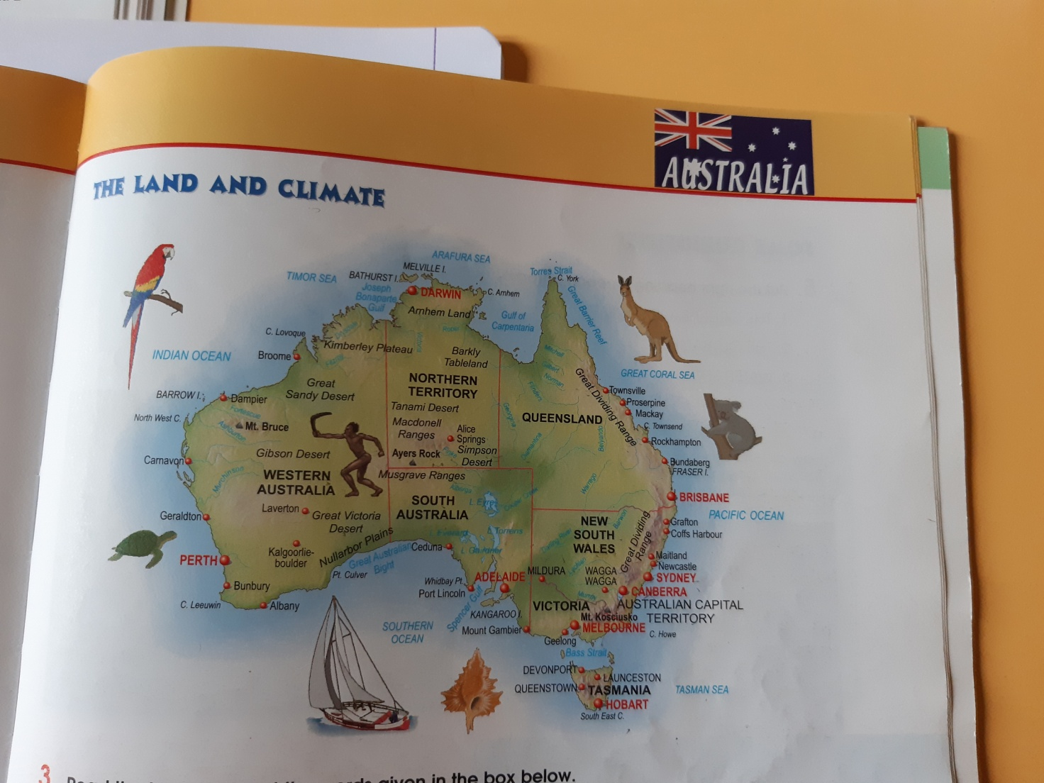
Svolgi gli esercizi 1. e 2.sotto al Fact File, leggendo e completando il testo sull’Australia. Poi, aiutandoti con l’esercizio 1.e 2. completato e facendo una ricerca, completa il factfile sull’Australia.
FACT FILE
AREA: …………………………………………… million square Kms (about 30 times larger than Britain)
POPULATION : nearly …………………………………….. million (about one third that of Britain)
FORM OF GOVERNMENT : Federal State
NUMBER OF STATES : ………………… (…………………………….., New South Wales, Queensland, …………………………., Western Australia and Tasmania)
NUMBER OF TERRITORIES: …………………. ( the Australian Capital Territory and the ………………………………………)
CAPITAL CITY : ……………………………………….
OTHER BIG CITIES …………………………………. (the biggest, with almost 4 million people), Melbourne, ………………………………., Adelaide, …………………………….., ………………………………….. and Hobart.
NATIONAL EMBLEMS ……………………………. and the emu
FLAG the Union Jack on a …………………………………… background and five …………………………. stars and a larger one
OFFICIAL LANGUAGE : ……………………………….
CURRENCY : the Australian …………………………….. and cents
Esercizio. 1
Read the text and insert the words given in the box below.
winter-cities-few-island-summer-deserts-March-meat-flat-peak

Australia is a federal state. The head of the state is the British monarch. It is made up of six states (Victoria,New South Wales, Queensland, South Australia; Western Australia and Tasmania) and two territories (The Northern Territory and the Australian Capital territory)
Australia is part of the continent of Oceani. It is situated in the southern emisphere, south of Indonesia and it is sorrounded by the Pacific and the Indian Oceans.
In Australia there are mountains in the east, a plain between the Great Dividing Range and the sea in the east, lowlands in the center, rainforests in the north, and deserts in the interior and in the west.
Because of erosion by wind and rain over the ages most of the country is ……………………………………………….. except for the land along the east coast, where we can find the mountains of the Great Dividing Range. Mount Kosciusco (2,229m) is the highest ………………………………….. in Australia.
A narrow plain separates the great Dividing range from the sea. This is where most Australians live and three major ……………………………………… - Sidney, Melbourne and Brisbane –are in this area.
The ……………………………….. of Tasmania is also part of this area even if it is 200 kms away from the mainland.
In the basin formed by the River Darling and the River Murray, people raise cattle and sheep. In fact, wool, …………………………….and wheat are the country’s main exports, along with sugar and fruit.
The interior of Australia is flat and infertile.
In Western Australia there are mainly ……………………………., so very ……………………………. people live there, except for the area around Perth.
Because of its position on the Tropic of Capricorn, Australia is the driest continent in the world. In the north it is hot and dry all year, in the south the summers are warm and the winters are cool. The seasons in Australia are the opposite of the seasons in the northern emisphere. …………………………………. lasts from June to August and ……………………………… lasts from December to February. Autumn starts in …………………………… . Spring starts in September.
Australia has got fascinating wildlife. There are typical animals such as kangaroos, platypuses, echidnas and emus. There are also reptiles, such as crocodiles and snakes.

Esercizio 2.
Australian Animals
Qui di seguito trovi la foto della scheda sugli animali australiani, svolgi gli es. 3a. e 3b.
Trovi la scheda sugli animali australiani, in allegato come file digitalizzato che puoi ingrandire incluso nella Cartella Attività n°5.
